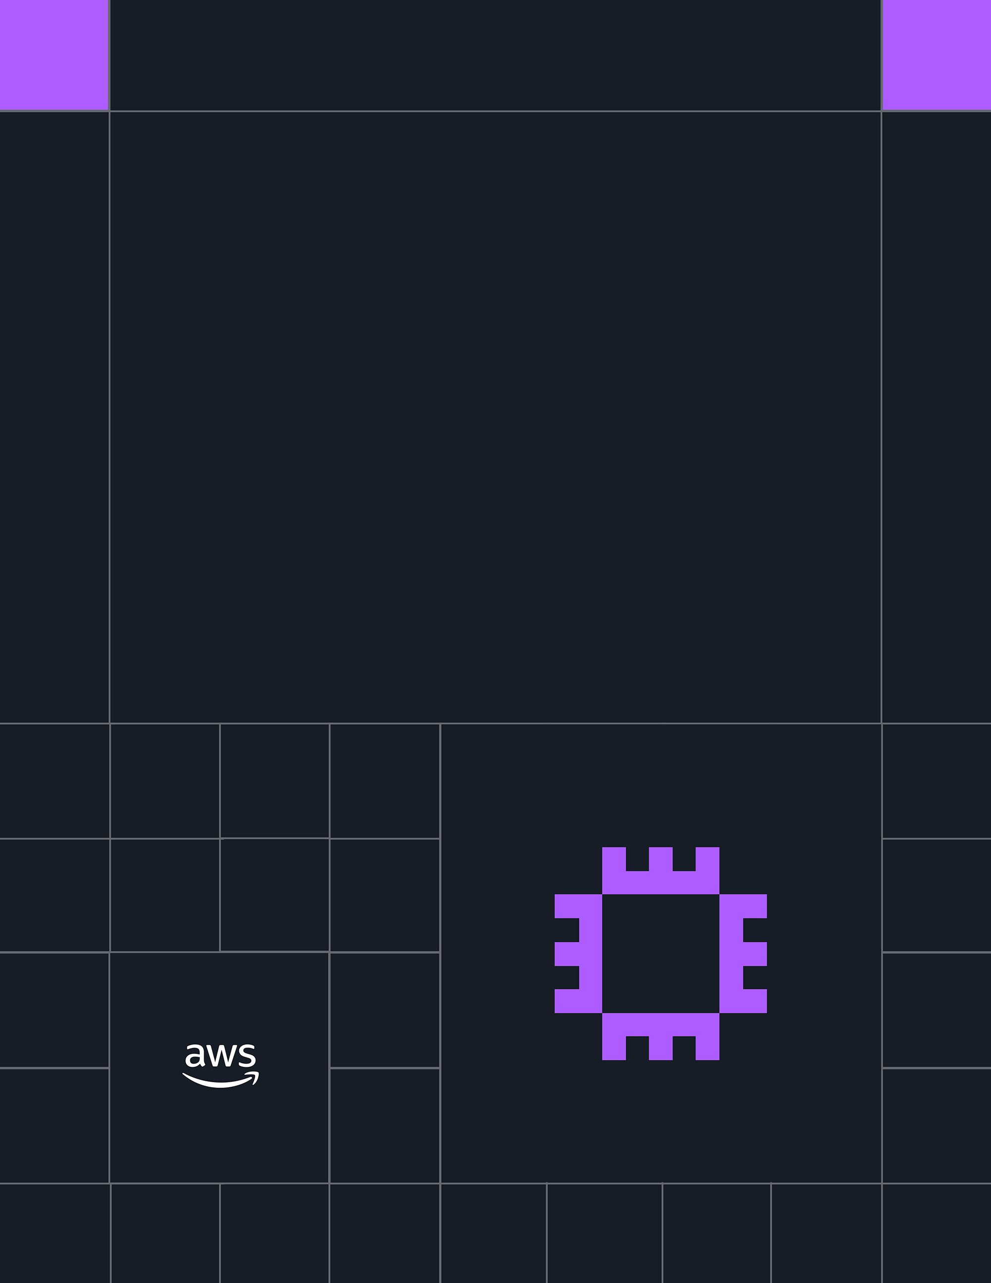
AWS Student Builder Group Community Day

2026 Playbook


TABLE OF CONTENTS
Introduction
Planning Timelines
Developing Your Team
Choosing Date & Venue
Agenda Content & Speakers
Budgeting & Finances
Branding & Design
Event Web Site & Promotion
Day-of Checklist
After the Event
Tips & Tricks
Additional Resources
Appendix: Sample Agendas & Inclusivity

© 2026, Amazon Web Services, Inc. or its affiliates. All rights reserved.
INTRODUCTION
AWS Student Community Days (SCD) are one-day, community-led conferences where event logistics and content are planned, sourced, and delivered by student community leaders with minimal guidance from AWS. SCDs are the culminating experience of an AWS Student Builder Group Leader, similar to how a student wraps up their academic degree with a senior thesis or capstone project. While a standard Student Builder Group event focuses on one topic, a Student Community Day features 3+ topics, sessions, and speakers to gather, educate, and celebrate with a wider array of audiences.
In 2024, 12 Student Community Days were hosted by AWS Student Builder Groups around the world. In 2023, 3 events of similar nature ran as Student Symposia. In 2025, we saw 33 SCDs organized by Group Leaders in a variety of regions around the world. A new record! For the latest list, please see AWS Builder Center.
The following pages provide broad guidance on how to plan a Student Community Day. For real examples from past SCDs, please check our Slack channel, Box folder, and/or speak to a SCD Advisor.

PLANNING TIMELINES
3 months before an event
- Gather a planning team to establish the dates, venue, and event tasks
- Develop a budget and decide how money will be handled.
- Start seeking funding from multiple sources.
- Begin sourcing speakers
2.5 months before
- Finalize venue and catering (if applicable)
2 months before
- Customize creative assets
- Choose speakers and finalize outline

1 month before
- Promote event publicly and open registration
- Gather volunteers
2 weeks before
- Confirm speakers and publish finalized list of sessions
1 week before
- Send promotional last chance email/social media posts (if needed)
- Create and share a list of day of logistics with volunteers
- Host a preparatory call with speakers

2 days before
- Send reminder email/social media posts
Event Day
- Drive attendees to register for AWS Builder Center
- Publicize code of conduct
- Capture event feedback
- Document everything
Within 1 week after the event
- Send thank you email with slides (if applicable)
- Report event metrics to stakeholders

DEVELOPING YOUR TEAM
Group Leaders and their event planning team are responsible for organizing the Student Community Day, with minimal support from the AWS team.
To plan event logistics and source session topics, we suggest that you form a Planning Committee comprised of Group leadership and other members. The Committee is in charge of all elements of event planning/logistics, as well as content, session tracks, speaker selection, and speaker preparation.
After establishing a Committee: assign each other various tasks, such as:
- Agenda & speaker selection
- Marketing
- Financials
- Venue selection
- Food/beverage (if applicable)
A project plan on a shareable document site to track tasks, owners, deadlines, and statuses has shown to be helpful in maintaining expectations and sharing workload.
Samples from the Philippines: How to establish responsibilities.
Outside of the Committee, establish a Volunteer Leader to direct volunteers upon arrival, as Committee members will be very busy throughout the day of the event. It would also be helpful to establish a group chat just for volunteers and organizers to quickly remedy issues that will arise throughout the day.
We recommend sourcing volunteers for positions such as: session time keepers, tech checkers, microphone runners, greeters, help desk attendants, live social media managers, discussion moderators, and set up/take down assistants.

CHOOSING DATE & VENUE
When selecting a date, keep in mind your institution’s schedule for exams, holidays, and breaks. Pick a time and place when students aren’t too busy with preparing for exams but are still available on campus. Consider holding your event on a day when fewer scheduling conflicts exist for students.
Student Community Days may be hosted in-person or hybrid mode. Before all the planning and executing, make sure to secure the venue first. Securing or tentatively-booking the venue should be the most urgent priority. If your event has an online component, we recommend using platforms like Streamyard or Twitch. Having reliable internet will be especially important for events involving online content.
The projected size of your event and how many concurrent sessions (tracks) you need to host may drive your venue selection. For a single track event, you can reserve a large conference hall that has space for self-serving lunch. For a two-track event, two rooms will be needed with a third area for lunch or refreshments. Be frugal by holding your event on-campus or another free or low-cost venue. As much as possible, your venue should be free.
Make sure that your venue has enough power outlets and adequate AV resources for your speakers, as well as microphones and a way to share slides on a large screen. Make sure it also has adequate internet and test all of these variables well before the event.
For a Student Community Day of any size and venue, a best practice is to have back-up plans and supporting resources (where available). Consult your venue’s IT support on ways to provide reliable internet.

AGENDA CONTENT & SPEAKERS
AWS does not have direct ownership of your agenda creation and speaker sourcing. SCDs are planned, sourced, and delivered by the Student Builder Group(s)’ Student Community Days Committee, with minimal guidance from AWS.
Successful Student Community Days typically deliver technical content through breakout sessions with live demos, hands-on workshop, and other interactive comments.
To source speakers, a call-for-presentations (CFP) can be made, allowing community members to submit talk ideas. Many organizers use platforms like Papercall.io and Sessionize to advertise a call-for-papers. We also recommend posting the CFP on the registration website and the registration confirmation email.
Local AWS Heroes, AWS Community Builders, AWS User Group Leaders and members, institution faculty, fellow students, Alumni Group Leaders, and past speakers are all good candidates for speakers. Presenters should be sourced from a variety of experiences, not solely AWS employees.
Since speakers’ familiarity with Student Builder Groups may vary, make sure to have a 30-minute online orientation with all the speakers, prior to the event.
You must ensure that all speakers and attendees agree to abide by the AWS Code of Conduct.

BUDGETING & FINANCES
Begin the budgeting process by collecting estimates for all potential expenses as early as possible. This includes but is not limited to venue, food, printing, AV equipment, and swags. We recommend adding a buffer of 10% on top of your estimates to account for last-minute adjustments.
Once your budget draft is ready, categorize all line items and group them under categories such as:
- Agenda & speaker selection
- Marketing
- Financials
Here is a sample budgeting template to organize and calculate your needs.
Example: Swag and Food Allocation
Suppose your total budget is $1500 USD, and you plan to distribute swags and food to attendees. Let’s say:
- Food costs $2 per attendee
- Swags (e.g., pins, stickers, lanyards, keychains, brochures) cost $3 per attendee
- This totals $5 per attendee

If you allocate $1000 USD specifically for attendee-related items (food + swags), then you can accommodate:

$1000 ÷ $5 = 200 attendees

This does not include your organizers, so ensure their meals and tokens are accounted for separately in the budget.
Be intentional about your spending. Swags and giveaways are great, but maximizing learning value and community impact should always come first.
After the event, organize receipts for expenses spent. A template is available in our Box folder here. Due date: 14 days from event date. Email your completed excel file to StudentBuilders@amazon.com

BRANDING & DESIGN
When referring to AWS Student Builder Groups Student Community Day, please use: “AWS Student Builder Groups Student Community Day.” All mentions of Student Community Day should be capitalized. When referring to your specific event, please use AWS Student Builder Groups Student Community Day [city or region name].
All Student Builder Group and AWS-related logos and fonts are provided in Box. Please do not recolor or stretch the logos provided. The primary font used is Amazon Ember.
For printed materials, past SCD Group Leaders recommend having generic designs that can be reused for different events and purposes throughout the year.

EVENT WEBSITE & PROMOTIONS
We recommend using your Student Builder Group page on Meetup.com to organize the event. If you choose to use another event registration platform like Eventbrite or Konfhub, include the link on your Meetup page as well for cross-promotion. The SCD must be posted on Meetup.com for it to count towards your badging.
To promote your event, the best practice is to use a multi-channel approach. Leverage Meetup, email, website content, social media, and word-of-mouth to promote the event.
Social media is an amazing tool for demand generation for the event. For instance, consider posting about speakers, promoting sponsors, and promoting after event activities on Twitter, Facebook, and other social media used locally. You could also create and send ready-to-use marketing materials to encourage sponsors to promote the event on their channels as well. Please use the #AWSStudentBuilderGroup hashtags on social media.
Organizers can assign someone to serve as on-site event coverage and to record live streams of the event.
To attract attendees, we recommend sending the following notifications to your membership on Meetup.com and via your campus’s chatrooms and messaging apps:
- Registration open email that includes date, time, location, agenda, why students should attend, and a description of the event.
- Reminder email 3 days before to remind attendees to attend, conference logistics (check-in location, parking, etc.), and any requirements needed before arrival. This is especially helpful, as registrants may have often forgotten they registered.
- Thank you email after the event with presentation decks, photos, video attachments, upcoming events, and a link to the post-event survey.

DAY-OF CHECKLIST
- Assign a lead volunteer to assign tasks to volunteers.
- At your check-in desk, ask all attendees to join AWS Builder Center by printing this sign. If you have a digital screen at check-in, you can also display this digital sign.
- Publish a list of set up, maintenance, and clean up tasks for volunteers either digitally or via printout.
- Set up a group chat for volunteers to communicate throughout the day to alleviate urgent issues and decrease the need to search the building for others.
- Do a walk through or send a recorded walk through so that volunteers are fully aware of the day’s activities and can answer questions if needed. Check in desk volunteers should be very knowledgeable of all conference plans.
- Assign a dedicated team to check in and take care of guests. Collect email addresses of any walk-in attendees.
- Make sure all volunteers are aware of when set up starts, when it is time to rearrange rooms, when clean up starts.
- Create and share a run-of-show document that explains the timing and responsibility for set up, name tag distribution, speaker/food arrivals, speaker introductions, and etc.
- Direct attendees to complete the anonymous survey for feedback at the end of the day. (s12d.com/aws-scd26)

AFTER THE EVENT
We recommend using your Student Builder Group page on Meetup.com to organize the event. If you choose to use another event registration platform like Eventbrite or Konfhub, include
sponsors to promote the event on their channels as well. Please use the #AWSStudentBuilderGroup hashtags on social media.
Organizers can assign someone to serve as on-site event coverage and to record live streams of the event.
To attract attendees, we recommend sending the following notifications to your membership on Meetup.com and via your campus’s chatrooms and messaging apps:
- Thank sponsors, speakers, and everyone who helped make the event a success
- Debrief and document learnings with event organizers
- Settle finances and documentation required for AWS seed funding
- Celebrate learnings and photos on social media
- Clean up attendee list for badging
- Claim your Platinum level badge and upload attendee list
- Considering issuing a certificate of recognition for top performing volunteers
- Send follow-up communications to attendees with information about upcoming events or opportunities
- Measure impact of your SCD. Within 1 week after your event, did your membership numbers grow? Does your social media page grow to have more likes or followers?

TIPS & TRICKS
When planning for an in-person event:
- Ensure that catering accommodates those with food allergies or dietary restrictions
- Try to offer energy boosting snacks to provide attendees with enough stamina to maintain focus throughout day
- Provide easily available A/V power for laptop/device charging
- Make sure wireless information is clearly posted in a place that is easy to see and will not move
- Prepare signage (welcome signs, agenda signs, directional signage etc.)
- Plan for transportation, directions, and parking

When planning for a hybrid event with online attendees:
- Set up reliable technical infrastructure with backup systems and dedicated IT support for streaming, audio, and video
- Use interactive tools (polls, Q&A, chat) that work for both in-person and virtual attendees to ensure equal participation
- Optimize room setup with proper camera angles, professional audio equipment, and a dedicated virtual moderator
- Create opportunities for interaction between virtual and in-person attendees through mixed breakout rooms and shared activities
- Conduct full rehearsals with speakers and test all technical elements to ensure smooth transitions between virtual and in-person components
- Have clear communication channels and dedicated support staff to address both audiences’ needs throughout the event


ADDITIONAL RESOURCES
#scd-organizers Slack channel for questions and discussion regarding SCD
To attract attendees, we recommend sending the following notifications to your membership on Meetup.com and via your campus’s chatrooms and messaging apps:
- This dedicated channel includes SCD Advisors who are Alumni Group Leaders who have hosted successful SCDs in the past.
- The channel is managed by Nayoung [AWS].

SCD Box folder for templates, examples, and more.

APPENDIX: AGENDA
Make sure to build in breaks to keep your audience engaged!
Sample Agenda
10:00am – 10:30am | Check-in & Registrations
10:30am – 11:00am | Welcome from the Committee
11:00am – 11:30am | Keynote
11:30am – 12:30pm | Part 1 of Track(s)
12:30pm – 1:30pm | BREAK
1:30pm – 2:30pm | Part 2 of Track(s)
2:30pm – 3:30pm | Part 3 of Track(s)
3:30pm – 3:45pm | BREAK
3:45pm – 4:30pm | Questions & Answers / Panel
4:30pm – 5:00pm | Closing

For more examples from past SCDs, check out the Additional Resources.


APPENDIX: INCLUSIVITY
Amplify the voices of all technologists including women and those from underrepresented backgrounds, cultures, and accessibility needs.
Don’t fall prey to “tokenism,” a superficial effort to include minorities. For example, just because we have one person with a disability on stage that doesn’t mean we can’t have two, and one person don’t represent the opinions of all people with disabilities. All speakers are technologists first, who happen to offer a diverse perspective second.
Make the event as accessible as possible to those with disabilities. Here are some tips on how to create an accessible culture for both speakers and audiences.
For those that are deaf or hard of hearing:
- Look at the person you are talking to, not the interpreter (if present)
- Face the person or write things down, don’t raise your voice
- Have a sign language interpreter (or two) available, so they can swap out for the other

For those that are blind or low vision:
- Offer captioning screens on stage and facing the audience, taking the size of the room into account
- Identify yourself and use verbal descriptions

For those with physical accessibility needs:
- Ensure your event is equipped with a ramp for wheelchair access

